

Time Management Process©
For [Project Name]

Document Control

Document Information
© | Information
Document Id | [Document Management System #]
Document Owner | [Owner Name]
Issue Date | [Date]
Last Saved Date | [Date]
File Name | [Name]

Document History
Version | Issue Date | Changes
[1.0] | [Date] | [Section, Page(s) and Text Revised]

Document Approvals
Role | Name© | Signature | Date
Project Sponsor

Project Review Group©

Project Manager

Quality Manager
(if applicable)

Procurement Manager
(if applicable)

Communications Manager
(if applicable)

Project Office Manager
(if applicable)

Table of Contents

Template Guide 1
1 Time Management Process 2
1.1 Overview 2
1.2 Document Timesheet 4
1.3 Approve Timesheet 4
1.4 Register Timesheet 5
2 Time Management Roles 6
2.1 Project Staff Member 6
2.2 Project Manager 6
2.3 Project Administrator 6
3 Time Management Documents 7
3.1 Timesheet 7
3.2 Timesheet Register 7

Template Guide

What is a Time Management Process?

The Time Management Process is the method by which time spent by staff undertaking project tasks is recorded against the project. Recording the actual time spent undertaking tasks on a project has various purposes. It is used to:

- Calculate the total time currently spent against each individual task and therefore the total staff cost of undertaking each task on the project
- Identify any task slippage on the project plan, thereby enabling the Project Manager to control the level of resource allocated to each task
- Identify the percentage of each task completed plus any outstanding work required to be undertaken to complete the task in its entirety. ©

Time Management is undertaken by completing the following processes:

- Document Timesheet
- Approve Timesheet
- Register Timesheet.

When to use a Time Management Process

Although the Time Management Process is usually undertaken after the Project Plan has been formally documented and the project is underway (i.e. during the ‘Execution’ phase of the project), timesheets may be completed at any phase of the project if requested by the Project Manager. For instance, it may be deemed necessary that timesheets be recorded by all project staff at all phases of the project (including initiation, planning, execution and closure) to ensure that the full costs of the project are captured.

If timesheets are not recorded, it may be difficult to accurately assess the level of time spent undertaking project tasks and therefore become impossible to manage the project management constraints of time, cost and quality. ©

How to use this template
This document provides a guide on the topics usually included in a Time Management Process document. Sections may be added, removed or redefined at your leisure to meet your particular business circumstance. Example tables, diagrams and charts have been added (where suitable) to provide further guidance on how to complete each relevant section.

Time Management Process

Overview

Provide an overview of the Time Management Process. For example:

The Time Management Process is undertaken to accurately record the actual time spent by staff to complete the project tasks delegated by the Project Manager. Time Management comprises 3 generic processes: ©

- Document Timesheet
- Approve Timesheet
- Register Timesheet
Timesheets will be undertaken by all project members, including:

- Project staff
- Project contractors
- Project suppliers
- The Project Management team

List the core principles involved within the completion of timesheets. For example:

- Time must be recorded on timesheets in at least 1 hour blocks to ensure that the full nature of the activity being undertaken is understood
- Timesheets must be completed weekly and submitted to the Project Manager for approval by the following Monday (for the prior week's entries)
- Timesheets must include information on all activities and tasks undertaken during the time entry period
- Each time entry must be recorded against an Activity ID and Task ID as specified in the Project Plan
- Timesheets will be approved only if all time undertaken on the project is accurately recorded within the timesheet. ©

The following diagram depicts the processes and procedures to be undertaken to document, approve and register timesheets within the project. Where applicable, Time Management Roles have also been identified:

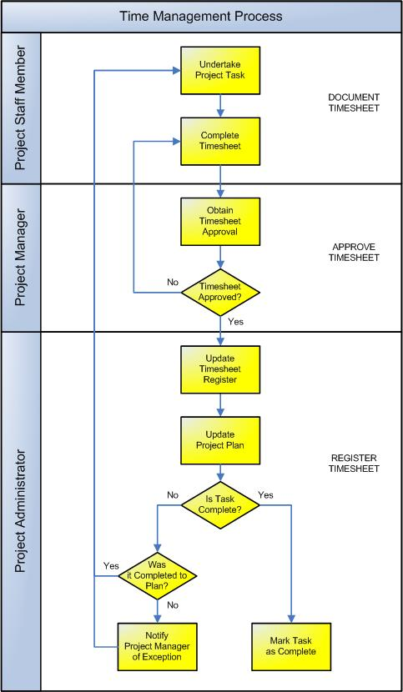

Document Timesheet
This process involves the capture of information relating to the time spent undertaking each task on the project. The following procedures are undertaken:

Undertake Project Task
Time management is based primarily around the completion of project activities and tasks. The first process within Time Management is the execution of a particular activity or task, as referenced in the overall Project Plan. Time spent undertaking each task will be recorded for the entire duration of the completion of the task. Time may be recorded for all project tasks at all phases of the project, including Initiation, Planning, Execution and Closure.

Complete Timesheet
From the moment time is spent on undertaking a particular task, it must be recorded on a physical project timesheet. Timesheets exist in various forms, including paper-based, spreadsheet or software-based formats. Regardless of the method used to capture time spent, time must be recorded at an agreed level of detail as defined upfront by the Project Manager. The most accurate method of capturing timesheet information is to request that project staff record time in their timesheet as they undertake each task, as opposed to waiting till the end of the reporting period. ©

Approve Timesheet
Timesheets must be submitted by each member of the project team to the Project Manager for approval on a regular, pre-determined basis. (It is common to submit timesheets on a weekly basis). The Project Manager will then complete the following steps prior to approving each timesheet:

- Confirm that the tasks undertaken were valid tasks as identified in the Project Plan
- Confirm that the staff member was in fact the resource allocated to the task
- Decide if the outcome of the task is reasonable, considering the time spent.

Based on the above information, the Project Manager will:
- Approve the timesheet and forward it to the Project Administrator or
- Request further information from the Project staff member or
- Decline the timesheet and raise a staff issue. ©

Register Timesheet
The approved timesheet is then ready to be logged / registered. The following procedures are undertaken:

Update Timesheet Register
The details from the timesheet are formally recorded in a Timesheet Register. The Timesheet Register records the full details of all approved timesheets, thereby enabling:
- The Project Plan to be updated, with a summary of the time recorded against each task
- The cost of each staff member to be calculated and monitored throughout the project
- Monitoring and control of standard time vs overtime undertaken on the project. ©

Update Project Plan
On a regular basis (typically, weekly), the total time recorded against each project task within the Timesheet Register is recorded against the Project Plan. This enables the Project Administrator to:

- Produce a view of the overall progress of the project to date
- Identify any slippage (i.e. activities which are outstanding and were due to be completed by the current date)
- Identify any exceptions (e.g. where the number of hours undertaken exceeds the original budgeted hours planned).

Notify Project Manager of Exception
The Project Administrator then provides the Project Manager with a copy of the updated Project Plan and raises any areas of slippage or exception. It is then up to the Project Manager to take action based on the extent of the deviation from plan. Examples of actions taken may include:

- Changing the individual / amount of resource allocated to the task
- Allocating additional funds to complete the task
- Requesting assistance from an external supplier to complete the task
- Raising a project issue for action by the Project Board / Sponsor.

Mark Task as Completed
Once the task has been completed, the respective tasks listed within the Timesheet Register and Project Plan are marked as 100% complete. After a task has been marked as 100% complete, no further time can be allocated against it for the duration of the project. ©

Time Management Roles

Define the roles and responsibilities for all resources involved with the completion, approval and registration of timesheets within the project. The number and types of roles will depend on the size and complexity of the project. For instance, on a small project the Project Manager may fill the role of Project Administrator. Regardless of who actually fills each role, it is important to identify the generic timesheet responsibilities required to be undertaken on the project. Examples include:

Project Staff Member
The Project Staff Member is responsible for:

- Undertaking each delegated task to the best of his/her abilities
- Completing regular Timesheets to the level of detail requested
- Submitting timesheets to the Project Manager as required
- Providing the Project Manager with further information surrounding the completion of each task, if required. ©

Project Manager
The Project Manager has overall responsibility for the Time Management Process, including:

- Delegating tasks to project staff members and providing them with the resources and support required to undertake each task effectively
- Ensuring that all staff are informed of the Time Management Process, that they understand when timesheets need to be submitted, to whom and in how much detail
- Reviewing and approving all timesheets on the project
- Creating actions plans to address deviations from plan
- Resolving all timesheet issues with staff members and raising any generic time-related issues to the Project Board / Sponsor for action.

Project Administrator
The Project Administrator manages the day-to-day timesheet process by:

- Providing all staff with the basic timesheet template for completion
- Ensuring that all timesheets are completed on time and to the required level of detail
- Checking that all timesheets have been reviewed and approved by the Project Manager
- Obtaining further information from staff members, should it be requested by the Project Manager when reviewing timesheets for approval
- Loading the details of all approved timesheets into the Timesheet Register
- Entering the summarized Timesheet Register information into the Project Plan and identifying any slippage / exceptions for the Project Manager's attention. ©

Time Management Documents

List any other documentation used to undertake the Time Management Process within the project. For example:

Timesheet
The ‘Timesheet’ is the document completed by project staff members to formally record the actual time spent undertaking a project activity or task. Insert a template for the Timesheet here to show how time will be recorded by staff members on the project. (NB Refer to the Method123 ‘Timesheet Form’ template for a complete example)

Timesheet Register
The ‘Timesheet Register’ is the central log / database where all timesheet information is formally recorded for the project. Insert a template for the Timesheet Register here to show how time will be logged for the project. (NB Refer to the Method123 ‘Timesheet Register’ template’ for a complete example)

